

**Final Report**

**Skill Development Project III – ICT 3206**

**Bachelor of Information and Communication Technology (Honors)**

Department of Information and Communication Technology

Faculty of Technology

Rajarata University of Sri Lanka

(*Leave this page blank*)

**Details of the Project**

|  |  |  |  |  |  |  |  |
| --- | --- | --- | --- | --- | --- | --- | --- |
| **Project Title** | : |  | | | | | |
|  |  |  | | | | | |
| **Group Number** | : |  | | | | | |
| **Group Name** | : |  | | | | | |
| **Submission Date** | : |  | | | | | |
| **Details of the Group Members** | | | | | | | |
| **Name** | | | | | **Registration ID** | **Index No.** | **Signature** |
|  | | | | |  |  |  |
|  | | | | |  |  |  |
|  | | | | |  |  |  |
|  | | | | |  |  |  |
|  | | | | |  |  |  |
|  | | | | |  |  |  |
| **Details of Supervisor(s)** | | | | | | | |
| **Name** | | | : |  | | | |
| **Designation** | | | : |  | | | |
| **Department/ Unit/ Institute** | | | : |  | | | |
| **Contact Details** | | | : |  | | | |

**Guideline to fill the document**

1. Final report should elaborate the details with respect to the entire project.
2. Your final report content should tally with the Software Requirements Specification (SRS) and System Design Specification (SDS) which you have already submitted in the previous stages.
3. This final report should be prepared using a word processor, clear and coherent.
4. The content of each section in this document should be in detail and make the focal points stand out.
5. A student may have more than one supervisor. In such case, the details of all supervisors should be included on the document.
6. The student can attach additional pages.
7. The student must follow the IEEE format to make the reference list.
8. This document should be printed on both sides of A4 papers (do not print with colors).
9. Each figure/diagram should be numbered along with a caption. All figures/diagrams must be referred within the textual content. The figure number and caption must be placed at the bottom of the figure/diagram.
10. Each table should be numbered along with a caption. All tables must be referred within the textual content. The table number and caption must be placed at the top of the table.

**Submission Guidelines for the document**

1. The student must submit a soft copy of finalized document to the LMS, as an electronic book version (.pdf) on or before the submission date.
2. The student must submit the second version of the document to the LMS, after corrections made based on the feedbacks and comments of viva panel as an electronic book version (.pdf). In this case, recommendation and approval page of supervisor(s) and comments/ approval page of viva panel could be scanned and attached at the end of the document in order to make the final document in electronic book version (.pdf).
3. Meanwhile, a hard copy of the Revised Final document which is recommended and approved by the supervisor(s) (with signature(s)), must be submitted to the department.

**Table of Contents**

1 Introduction 1

1.1 Background of the project 1

1.2 Purpose and significance of the project 1

1.3 Scope of the project 1

1.4 Aim and objectives of the project 1

1.5 System design approach 1

1.6 Project Work Plan 1

2 System Requirement 2

2.1 Functional Requirements of the Project 2

2.2 Non-functional Requirements 2

3 System Design 4

3.1 Architectural Design 4

3.1.1 System Architecture 4

3.1.2 Component design 4

3.1.3 Processes and interaction design 4

3.1.4 Tools, libraries, special algorithms and implementation environment 4

3.2 Interface Design 4

3.2.1 PACT (People, Activities, Contexts, Technologies) analysis of the system 4

3.2.2 Interfaces (software/hardware) of the system 4

3.2.3 Design tools, techniques, templates 4

3.3 Data Management 5

3.3.1 Design tools, techniques 5

3.3.2 Conceptual database design 5

3.3.3 Logical database design and schema refinement 5

3.3.4 Physical database design 6

3.4 Hardware Design (if available) 6

4 Testing and evaluation 7

4.1 Testing plan 7

4.2 Testing 7

4.2.1 Unit testing 7

4.2.2 Integrated testing 7

4.2.3 System testing 7

4.2.4 Acceptance testing 7

4.3 Test results and conclusion of testing 7

5 Conclusion 8

5.1 Conclusions of the project 8

5.2 Lessons learned and skills earned 8

5.3 Recommendations for further improvements 8

6 References 9

7 Recommendation of supervisor(s) on the final Report 10

8 Viva presentation assessment team 11

9 Comments of the assessment team on viva presentation 11

**List of Figures**

**List of Tables**

# Introduction

## Background of the project

## Purpose and significance of the project

## Scope of the project

*\* explain the boundaries of your project*

## Aim and objectives of the project

*\* List the amended and finalized objectives and the aim of your project.*

## System design approach

*\* Explain the* ***Software Development Process model(s)*** *(Ex: Agile, SCRUM, etc.) and* ***Design Pattern(s)*** *(Ex: MVC, Client-Server, etc.) with respect to your project.*

## Project Work Plan

*\* Explain how the project was managed, include a detailed timetable with milestones and Gantt chart.*

# System Requirement

## Functional Requirements of the Project

|  |  |
| --- | --- |
| Priority Number |  |
| Function Name | *The system must do [requirement].* |
| Description |  |
| Input |  |
| Process |  |
| Output |  |
| Assumptions/ Constraints |  |

***Instructions to fill functional requirements:***

* Well-written functional requirements typically have the following characteristics:
  + **Necessary**. Although functional requirements may have different priority, every one of them needs to relate to a particular business goal or user requirement.
  + **Concise**. Use simple and easy-to-understand language without any unnecessary jargon to prevent confusion or misinterpretations.
  + **Attainable**. All requirements you include need to be realistic within the time and budget constraints set in the business requirements document.
  + **Granular**. Do not try to combine many requirements within one. The more precise and granular your requirements are, the easier it is to manage them.
  + **Consistent**. Make sure the requirements do not contradict each other and use consistent terminology.
  + **Verifiable**. It should be possible to determine whether the requirement has been met at the end of the project.
* Use the tabular format given above to describe functional requirements of your project.
* Give a number to each functional requirement considering their priority in the implementation process.
* The function can be starts with “The system must do [requirement].”
* Describe the nature of each functional requirement in “Description” row.
* Describe the working process of each functional requirement in “Process” row.
* List the input(s) with type.
* List the output(s) with type.
* List assumptions and constrains if exist.

## Non-functional Requirements

***Instructions to fill Non-functional requirements:***

* Note that you have to state the aspects of the expected features of your software and how to measure each of them clearly in the final product.
* Use following categories or other suitable categories to organize non-functional requirements.
  + Product requirements
    - Usability requirement
    - Efficiency requirement
    - Performance requirement
      * Space requirement
      * Reliability requirement
    - Portability requirement
  + Organizational Requirements
    - Delivery requirement
    - Implementation requirement
    - Standard requirement
  + External requirements
    - Interoperability requirement
    - Ethical requirement
    - Legislative requirements
      * Privacy requirements
      * Safety requirements
      * Security Requirements

# System Design

## Architectural Design

### System Architecture

*\* Write an overview of the system architecture. Include high-level diagrams such as block diagrams. Explain how the components of the final product works together.*

### Component design

*\* Include the* ***class diagram*** *of the system and give a description of it.*

### Processes and interaction design

*\* Describe the processes of the system using* ***sequence diagrams****.*

### Tools, libraries, special algorithms and implementation environment

## Interface Design

### **PACT (People**, Activities, Contexts, Technologies) analysis of the system

*\* Describe the four (04) aspect of PACT analysis based on your system.*

### Interfaces (software/hardware) of the system

*\* Describe interfaces (software/hardware) of the system using figures*

### Design tools, techniques, templates

## Data Management

### Design tools, techniques

*\* Describe the tools and techniques use to implement database in the system.*

### Conceptual database design

*\* Describe the ER diagram you draw in the system requirement specification (SRS) stage. Include detailed descriptions of data, relationships and constraints.*

### Logical database design and schema refinement

*\* Describe the enhanced ER (with Cardinalities, Normalization, Primary Keys, Foreign Keys, etc.) using UML format. Include refined-database schema. An example is given below.*

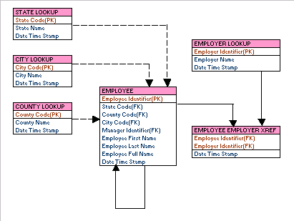

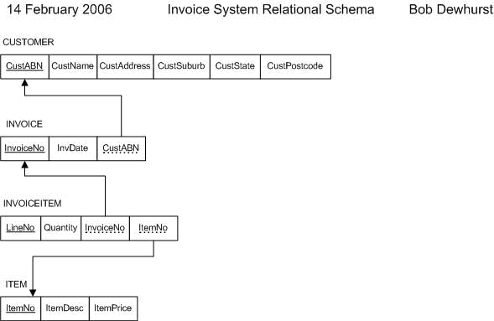

### Physical database design

*\* Describe the enhanced ER (by assigning each attribute with type, length, nullable, etc.) using UML format. Physical ER diagram represents how data should be structured and related in a specific DBMS it is important to consider the convention and restriction of the actual database system in which the database will be created. An example is given below*.

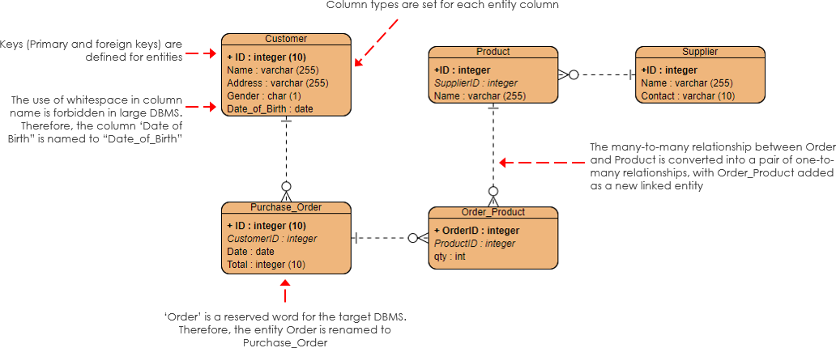

## Hardware Design (if available)

*\* Describe the hardware architecture using block diagrams. Explain how the communications works between the hardware components of the system.*

# Testing and evaluation

## Testing plan

*\* Explain how the testing was done, the costs involved, time frame, used software for testing*

## Testing

### Unit testing

*\* Write test cases*

### Integrated testing

*\* Write test cases*

### System testing

*\* Write test cases*

### Acceptance testing

*\* Write test cases*

## Test results and conclusion of testing

# Conclusion

## Conclusions of the project

## Lessons learned and skills earned

## Recommendations for further improvements

# References

*\* Follow the IEEE referencing guideline*

# Recommendation of supervisor(s) on the final Report

***(This section should be filled by the supervisor(s)).***

**Comments (if any):**

**I/We certify that, the student engaged continuously with me in developing the proposal and, I am confident that they are adequately competent to defend this viva.**

**Signature(s) of Supervisor(s):**

**Date:**

# Viva presentation assessment team

***(This section should be filled by the department)***

|  |  |  |  |
| --- | --- | --- | --- |
| **Date of viva presentation:** | |  | |
|  | | | |
| **Panel members** | **Name** | | **Department / Institute** |
| **Chair** |  | |  |
| **Member** |  | |  |
| **Member** |  | |  |
| **Member** |  | |  |
| **Member** |  | |  |

# Comments of the assessment team on viva presentation

***(This should be filled by the chair of the assessment panel. In case of revision or fail, needed revision or reasons to fail the viva presentation should be mentioned here)***

|  |  |
| --- | --- |
| **Result of the viva presentation** | **Excellent / Good / Pass with revisions / Fail** |
| **Score** |  |
| **Signature of the panel chair** |  |
| **Date** |  |